 | July 2015 SCHOOL-AGE
Sun | Mon | Tue | Wed | Thu | Fri | Sat
CLUB CREATIVE WILL BE CLOSED FROM JUNE 29TH- July 3rd |  |  | 1  15% OFF TUITION | 2 | 3 |   4
5  Camping  Week | 6  Making S’mores  Cooking Day  S’more Pizza | 7  Beaver Tail  Hiking and picnic  FREE  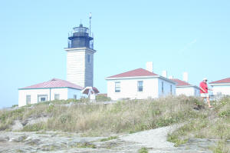 | 8    Making life size Tee-Pee’s with tubing and sheets | 9  Roger Wheeler State Beach  $3.00 | 10  Leisure Night  After hours  6:00-8:00 pm  SIGN UP 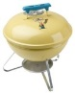  Hot Dogs/ Cheeseburgers | 11
12  Color Wars  Week | 13  Tye-Dye  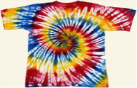  $2.00  Cooking Day  Confetti Cupcakes | 14  Lego Land  $20.00  INCLUDES LUNCH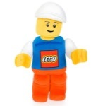  Drop off by 9:00  ( Arrival 11:00) | 15  Face painting  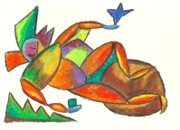  Creation: Using pastel chalk, water color, buttons, and foil on water color paper | 16  Tiogue Lake/ Briar Point  FREE | 17  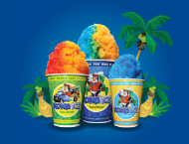  KONA ICE  $3.00  Sand art  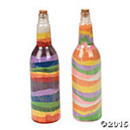 | 18
19  Under The Sea Week  ( Mural making will be divided into groups) | 20  Making cyclone bottles/ Recyclable soda bottle  Cooking Day  Making Fruit Salad and Dip |   21  Mystic Aquarium  $12.00 | 22  Create Murals  Sheets, outline, paint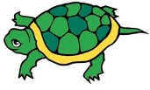 | 23  Roger Wheeler State Beach  $3.00  Work on mural | 24  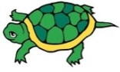  Finish Murals | 25
26  ** ALL TRIPS MAY BE SUBJECT TO CHANGE**  Mascaraed and Game Week | 27 -Mask making or Brush Head creations using paint brushes and model magic  Cooking Day  Making personal size pizzas | 28  Magician visits! Domino The Great  $8.00   | 29    Team games | 30  Tiogue Lake/ Briar Point  FREE | 31  KONA ICE    $3.00  BINGO  NIGHT / PIZZA/DANCE  6:00-8:00  SIGN UP | Notes:

